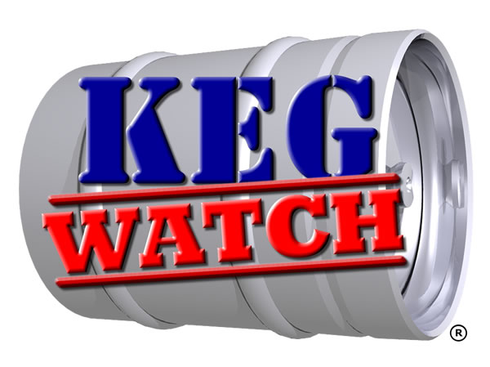

Any brewer disposing of their surplus or damaged containers should advise Keg Watch of the following:-

- The number of containers being scrapped.
- The type of metal – stainless steel / aluminium.
- Which accredited scrap yard is being used (list can be found on the Keg Watch and BBPA website).
- Date of disposal.
- Transport company to be used (where applicable).

The above information should reach the Keg Watch office prior to disposal in order to avoid us commencing investigations into legitimate scrapping operations.

Any surplus containers being put up for sale should not be advertised on EBAY (or equivalent online sites) as this will also prompt an investigation and could result in police involvement.

Any brewer wishing to sell their surplus containers please contact Keg Watch on 0808 100 1945.

